1. a. Jelaskan profile setiap kategori pengguna perangkat lunak Kelompok Anda.

* Admin
* Pengajar
* Pelajar

b. Apa yang dilakukan masing-masing kategori pengguna di aplikasi Anda.

* Admin : Admin dapat membuat kelas untuk pelajar dan pengajar, lalu admin dapat membuat akun untuk pelajar dan pengajar
* Pengajar : Membuat video conference, membuat form tugas, mengirim file materi
* Pelajar : Bergabung video conference, mengisi form tugas, mendownload materi

2.

Contoh code untuk login

| **import** Login **from** "../components/login/Login"; **import** Navbar **from** '../components/header/Navbar'   const login = () => {  **return**(  <div>  <Navbar/>  <Login/>  </div>  ) }  export default login; |
| --- |

| const Login = () => {  **return**(  <div className="grid place-items-center h-[80vh] mx-auto">  <div className="flex flex-col w-[450px] bg-white">  <h1 className="text-center text-[64px] font-[700] leading-[72px]">Mulai</h1>  <h1 className="text-center text-[48px] font-[700] leading-[96px]">Pembelajaranmu</h1>  <form>  <div>  <label className="text-[18px] font-[400] leading-[27px]">Email</label>  <input type="email" id="email" name="email"  className="w-full text-base px-4 py-2 border border-gray-600 rounded-[15px] focus:outline-none focus:border-black"  />  </div>  <div>  <label className="text-[18px] font-[400] leading-[27px]">Password</label>  <input type="password" id="password" name="password"   className="w-full text-base px-4 py-2 border border-gray-600 rounded-[15px] focus:outline-none focus:border-black"  />  </div>  <div className="flex justify-center space-x-3 font-[700] text-[18px] leading-[27px] py-4">  <div>  <input type="radio" value="Pelajar" id="Pelajar" name="Pelajar"  className="appearance-none rounded-full h-[28px] w-[28px] border border-black bg-white checked:bg-[#031D23] checked:border-black focus:outline-none transition duration-200 float-left mr-4 cursor-pointer"  />  <label className="m-0">Pelajar</label>  </div>  <div>  <input type="radio" value="Pengajar" id="Pengajar" name="Pelajar"  className="appearance-none rounded-full h-[28px] w-[28px] border border-black bg-white checked:bg-[#031D23] checked:border-black focus:outline-none transition duration-200 float-left mr-4 cursor-pointer"  />  <label>Pengajar</label>  </div>  <div>  <input type="radio" value="Admin" id="Admin" name="Pelajar"  className="appearance-none rounded-full h-[28px] w-[28px] border border-black bg-white checked:bg-[#031D23] checked:border-black focus:outline-none transition duration-200 float-left mr-4 cursor-pointer"  />  <label>Admin</label>  </div>  </div>  <button type="submit" className="w-full flex justify-center bg-black text-white p-3 rounded-[15px] tracking-wide font-[700] cursor-pointer" onClick={() => (console.log("Pencet"))}>  Masuk  </button>  </form>  </div>  </div>  ) }  export default Login; |
| --- |

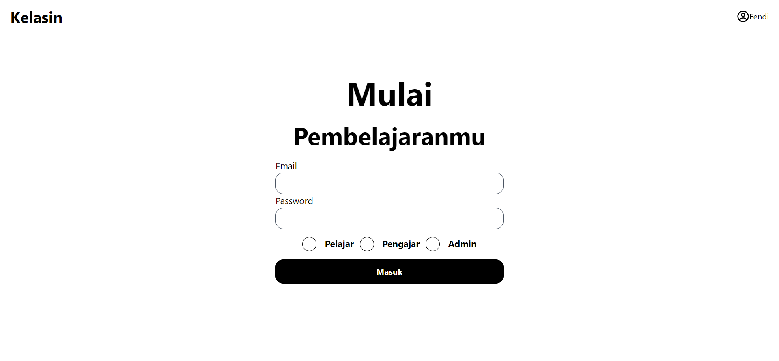

3. Contoh code untuk Dashboard Kelas

| import Head from 'next/head';  import Navbar from '../components/header/Navbar'; import Sidebar from '../components/sidebar/Sidebar'; import Footer from '../components/footer/Footer'; import Konten from '../components/Content-kelas/Konten'; import HeaderKelas from '../components/Content-kelas/HeaderKelas';  export default function DashboardKelas() {  const data = ["HOME","Kelas A","Kelas B", "Kelas C"];  const dataKelas = "KELAS A";  const konten = [  {id : 1, title : "Quiz 1", desc : "Kerjakan tidak boleh mencontek", button : "Kerjakan Quiz"},  {id : 2, title : "Video Conference", desc : "Video Conference 20/01/2022", button : "Join"},  {id : 3, title : "Materi 1", desc : "Silahkan Download materi ini", button : "Download Materi"},  ]  return (  <div className="bg-slate-200">  <Head>  <title>Home</title>  <meta name="viewport" content="initial-scale=1.0, width=device-width" />  </Head>  <Navbar/>  <div className='flex h-screen'>  <Sidebar data={data}/>  <div class="flex-row mx-auto">  <HeaderKelas data={dataKelas}/>  {konten.map((data, dataIdx) => {  return (  <Konten key={dataIdx} data={data}/>  )  })}  </div>  {/* <h1> Konten </h1> */}  </div>  <Footer/>  </div>  ) } |
| --- |

| const Konten = ({data}) => {  console.log(data)   return(  <**div** className="container rounded-lg mx-auto w-[900px] bg-[#FFF] mt-4 drop-shadow-md">  <**div** class="px-8 py-4">  <**p** class="text-[50px] text-black">{data.title}</**p**>  <**hr** class="border-t-[3px] border-gray-500 rounded"/>  <**p** class="text-lg">{data.desc}</**p**>  <**button** class="rounded-md mt-10 border-2 border-black py-2 px-3">{data.button}</**button**>  {/* <**p** class="text-[130px] text-black">{data}</**p**> */}  </**div**>  </**div**>  ) }  export default Konten; |
| --- |

| const Sidebar = ({data}) => {  console.log(data)    return(  <**div** className="pt-[30px] px-[30px] w-[250px] bg-white h-[84vh]">  <**p**>Pages</**p**>  <**div**>  <**ul**>  {data.map((data, dataIdx) => {  return( (dataIdx === 0) ?   <**li** key={dataIdx} className='pb-[10px]'>  <**div** className="border bg-[#053742] rounded-[7px] w-[177px]">  <**p** className="text-center text-[16px] p-[10px] text-white">{data}</**p**>  </**div**>  </**li**>  :  <**li** key={dataIdx} className='pb-[10px] border-b-2'>  <**div** className="rounded-[7px] w-[177px]">  <**p** className="text-center text-[16px] p-[10px]">{data}</**p**>  </**div**>  </**li**>  )  })}  </**ul**>  </**div**>  <**div** className="flex justify-center pt-[100px]">  <**button** className="p-[10px] bg-[#FE2F2F] w-full text-white rounded-[8px]">Keluar</**button**>  </**div**>    </**div**>  ) }  export default Sidebar; |
| --- |

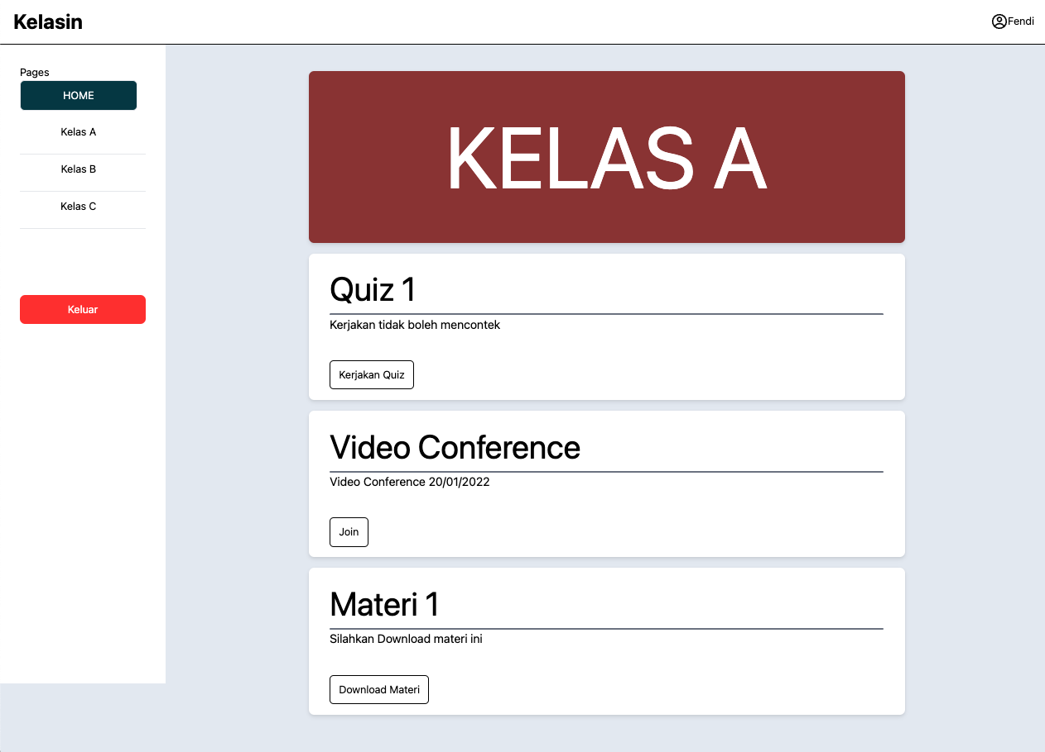

4. Contoh Code untuk Dashboard pengajar

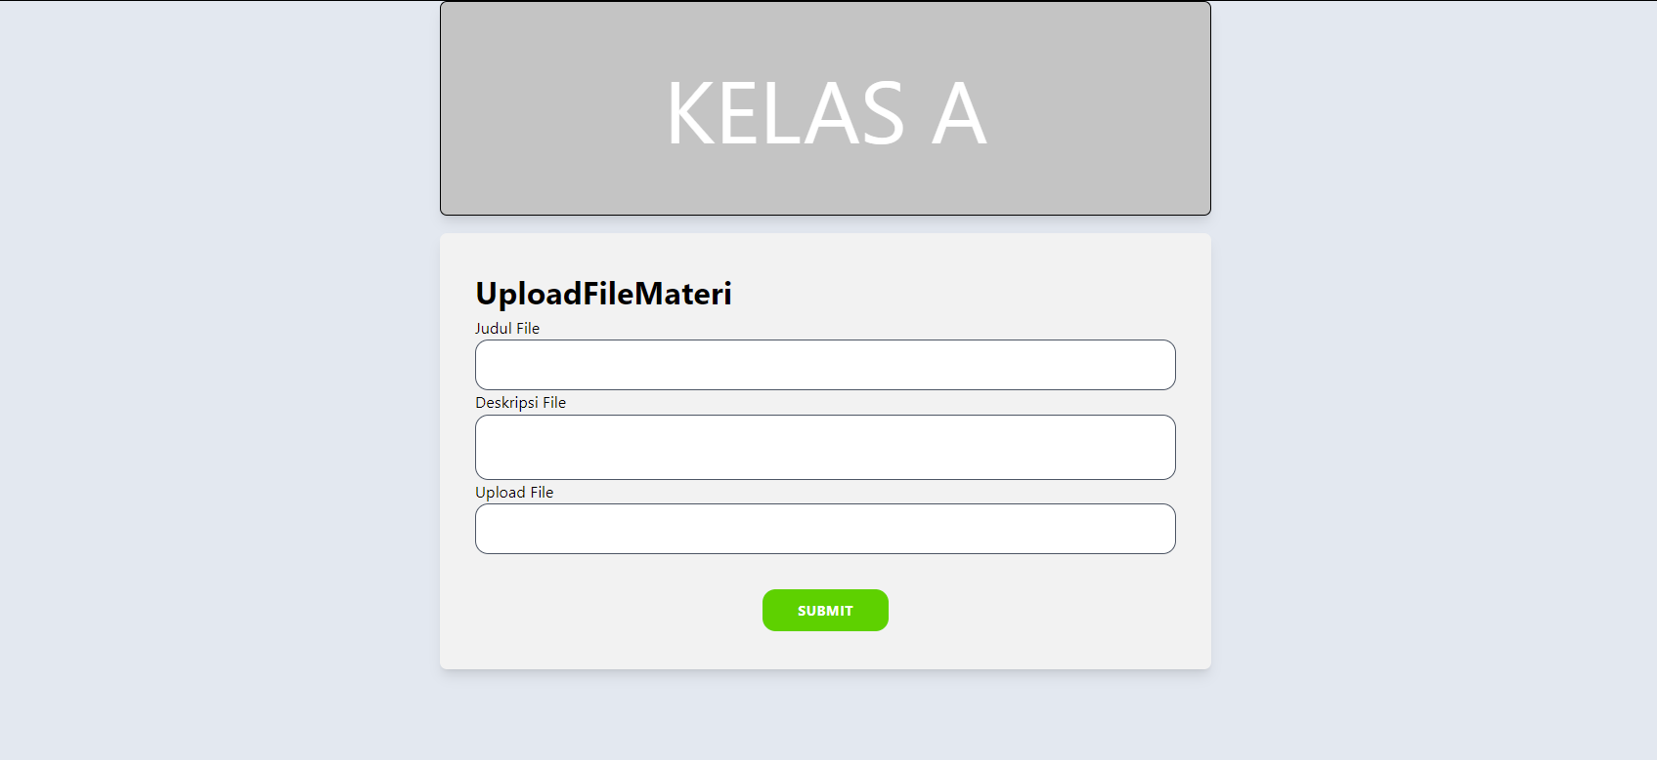

| export default function UploadF(){  return(  <div>  <div className='flex w-[877px] h-[245px] border-2 border-black items-center justify-center bg-[#C4C4C4] rounded-[8px] shadow-lg text-[100px] text-[white] '>  <h1>KELAS A</h1>  </div>  <div className='w-[877px] h-[496px] bg-[#F2F2F2] items-center justify-center rounded-[8px] shadow-lg p-10 mt-5'>  <h1 className="text-left text-[36px] font-[700] leading-[54px]">UploadFileMateri</h1>  <form>  <div>  <label className="text-[18px] font-[400] leading-[27px]">Judul File</label>  <input type="judul" id="judul" name="judul"  className="w-full text-base px-4 py-4 border border-gray-600 rounded-[15px] focus:outline-none focus:border-black"  />  </div>  <div>  <label className="text-[18px] font-[400] leading-[27px]">Deskripsi File</label>  <input type="text" id="deskripsi" name="deskripsi"  className="w-full text-base px-4 py-6 border border-gray-600 rounded-[15px] focus:outline-none focus:border-black"  />  </div>  <div>  <label className="text-[18px] font-[400] leading-[27px]">Upload File</label>  <input type="text" id="link" name="link"  className="w-full text-base px-4 py-4 border border-gray-600 rounded-[15px] focus:outline-none focus:border-black"  />  </div>  <div className="flex justify-center m-10">  <button type="submit" className="flex justify-center bg-[#48D118] text-white py-3 px-10 rounded-[15px] tracking-wide font-[700] cursor-pointer" onClick={() => (console.log("Pencet"))}>  SUBMIT  </button>  </div>  </form>  </div>  </div>    )  } |
| --- |